**Ex. No.: 12**

**Date:16.04.2025**

**File Organization Technique- Single and Two level directory**

**AIM:**

To implement File Organization Structures in C are

a. Single Level Directory

b. Two-Level Directory

c. Hierarchical Directory Structure

d. Directed Acyclic Graph Structure

**a. Single Level Directory**

**ALGORITHM:**

1. Start

2. Declare the number, names and size of the directories and file names.

3. Get the values for the declared variables.

4. Display the files that are available in the directories.

5. Stop.

**PROGRAM:**

#include <stdio.h>

#include <string.h>

struct Directory {

char name[10][20];

int count;

};

int main() {

struct Directory dir;

dir.count = 0;

int n;

printf("Enter the number of files: ");

scanf("%d", &n);

for(int i = 0; i < n; i++) {

printf("Enter the name of file %d: ", i + 1);

scanf("%s", dir.name[i]);

dir.count++;

}

printf("\nFiles in the directory:\n");

for(int i = 0; i < dir.count; i++) {

printf("%s\n", dir.name[i]);

}

return 0;

}

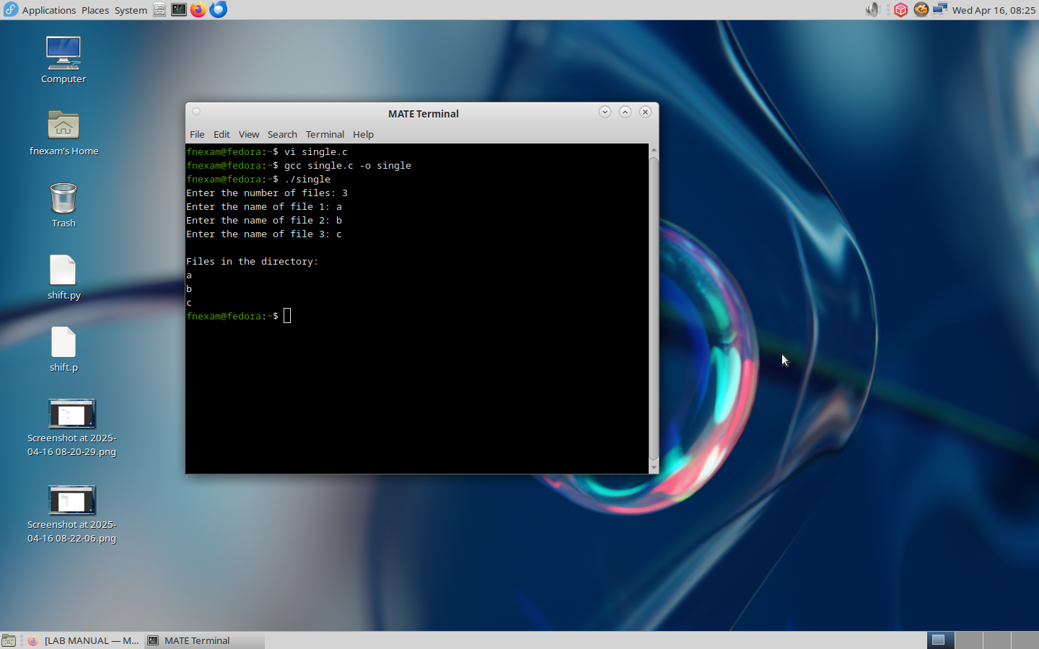

**b. Two-level directory Structure**

**ALGORITHM:**

1. Start

2. Declare the number, names and size of the directories and subdirectories and file

names.

3. Get the values for the declared variables.

4. Display the files that are available in the directories and subdirectories.

5. Stop.

**PROGRAM:**

#include <stdio.h>

#include <string.h>

struct SubDirectory {

char files[10][20];

int file_count;

};

struct Directory {

char dir_name[20];

struct SubDirectory subdirs[10];

int subdir_count;

};

int main() {

struct Directory dir;

printf("Enter Directory Name: ");

scanf("%s", dir.dir_name);

printf("Enter the number of subdirectories: ");

scanf("%d", &dir.subdir_count);

for(int i = 0; i < dir.subdir_count; i++) {

printf("\nSubdirectory %d:\n", i + 1);

printf("Enter number of files: ");

scanf("%d", &dir.subdirs[i].file_count);

for(int j = 0; j < dir.subdirs[i].file_count; j++) {

printf("Enter file %d name: ", j + 1);

scanf("%s", dir.subdirs[i].files[j]);

}

}

printf("\nDirectory Structure:\n");

printf("Directory: %s\n", dir.dir_name);

for(int i = 0; i < dir.subdir_count; i++) {

printf(" Subdirectory %d Files:\n", i + 1);

for(int j = 0; j < dir.subdirs[i].file_count; j++) {

printf(" %s\n", dir.subdirs[i].files[j]);

}

}

return 0;

}

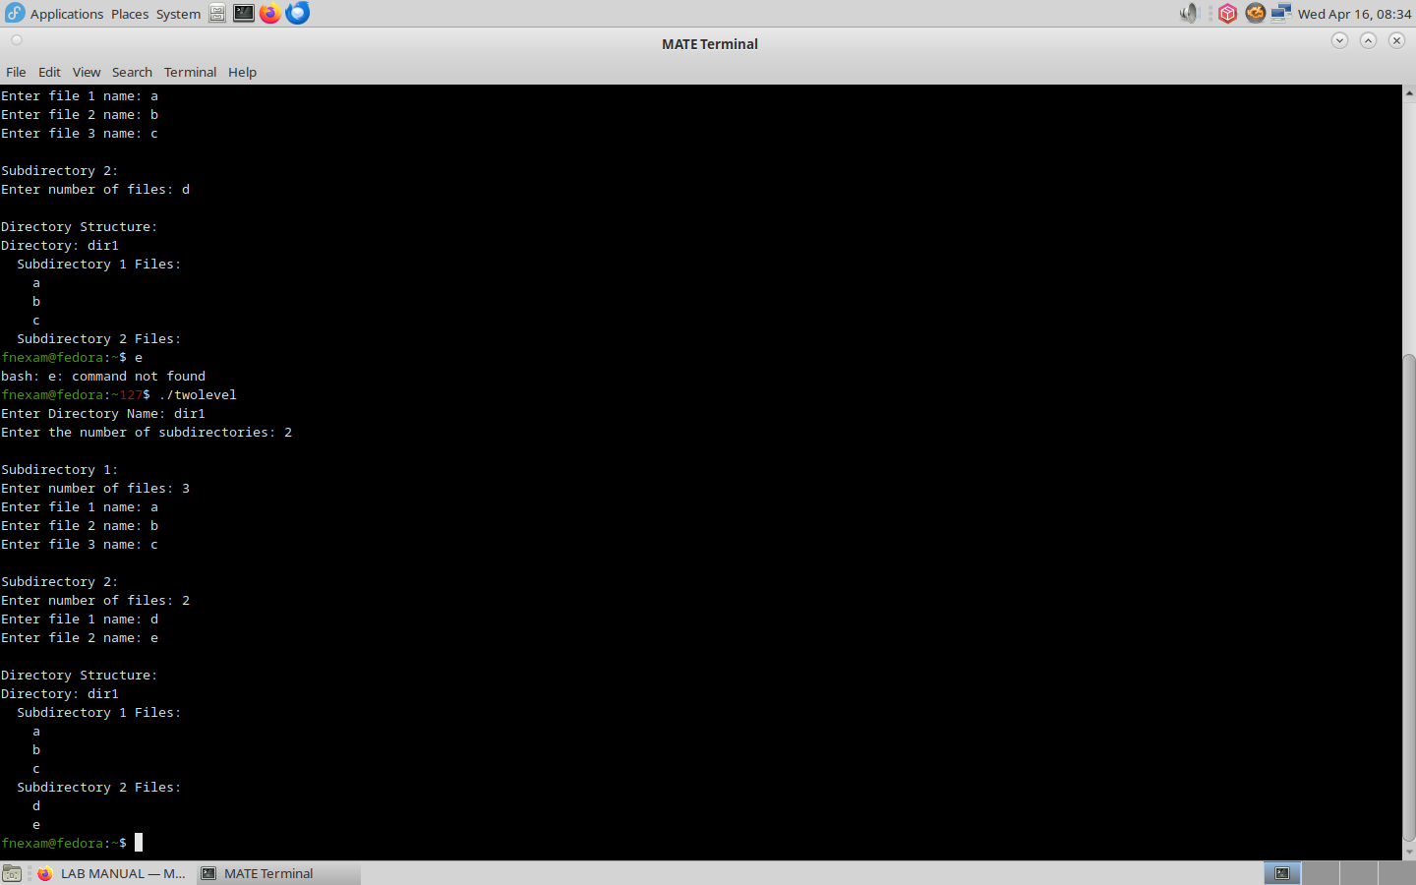

**RESULT:**

Hence, file organization technique has been executed successfully.